

# Information Technology Institute

# Digital Design and Computer Architecture

# Lab 1: FSM

# Submitted by: Ali Yehia Abdelmonem

**Sequence Detector of 011 using Moore and Mealy**

# Moore FSM Design

## State Transition Diagram for Moore FSM

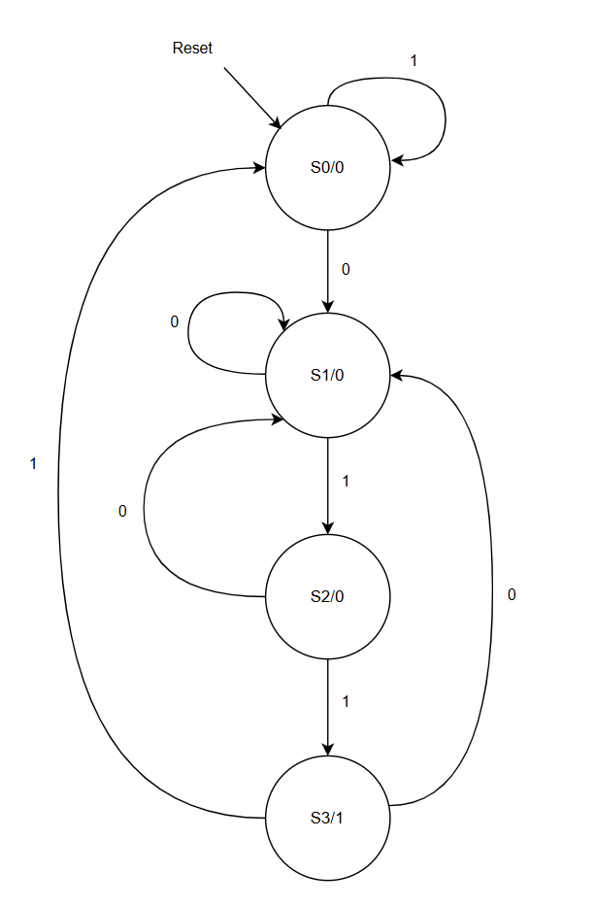

## Moore FSM VHDL Code

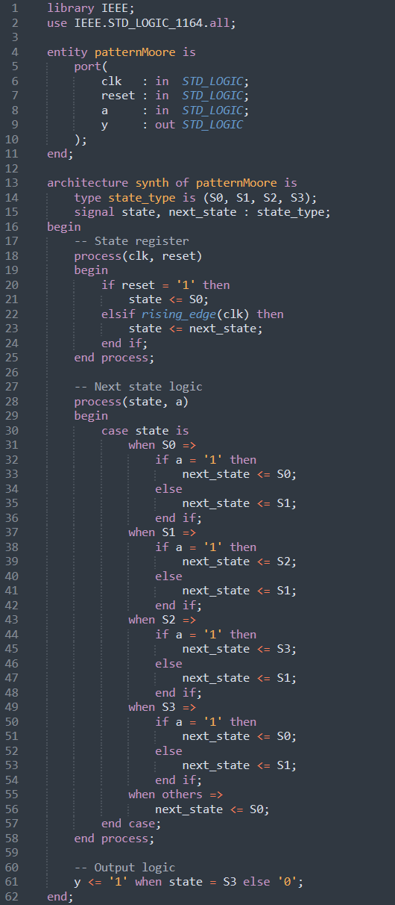

## Moore FSM Testbench Code

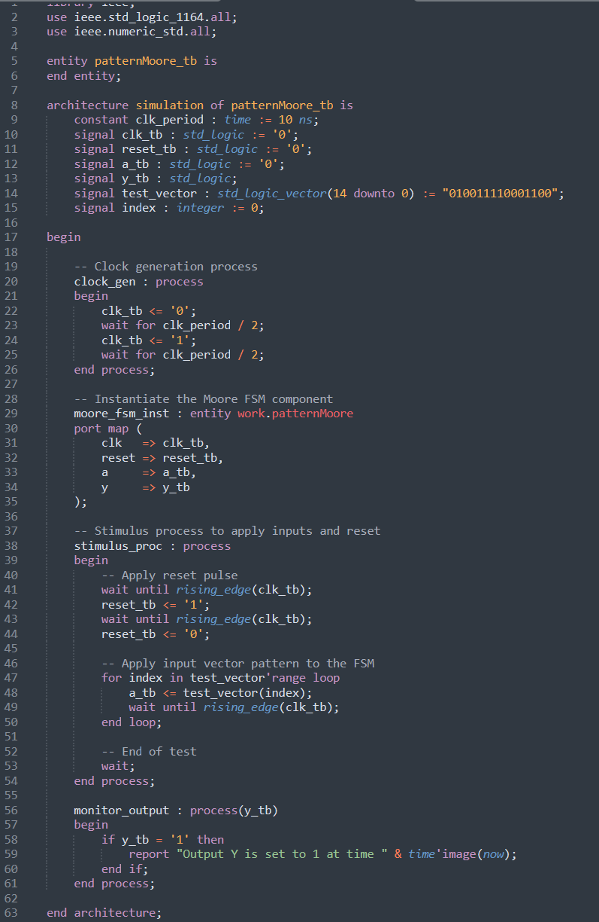

## Simulation Results

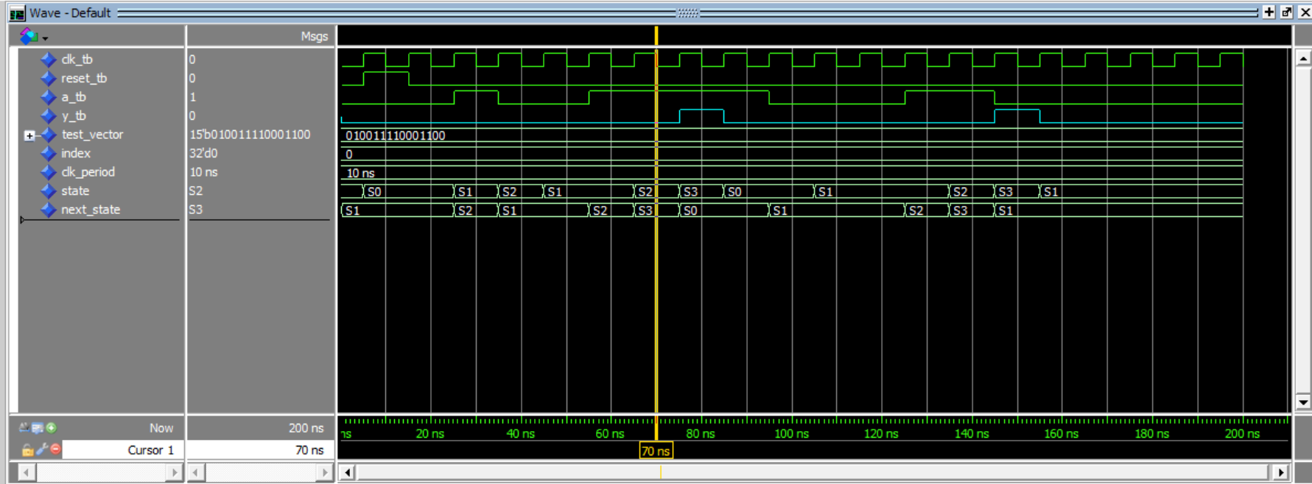

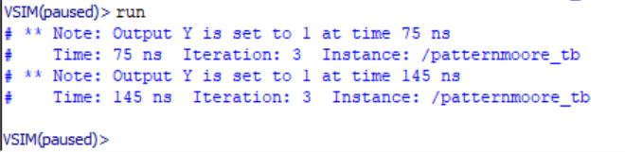

## Synthesis Results for Default Encoding (binary)

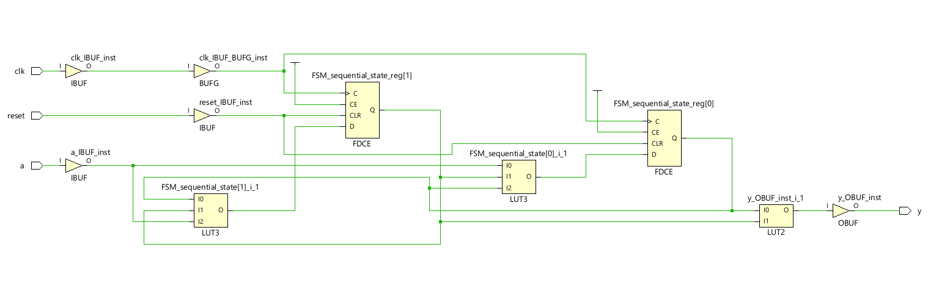

## Log File Output

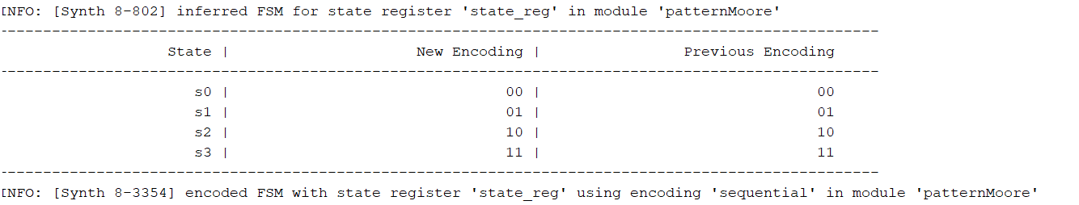

Figure ‎1‑1: Default State Encoding in Vivado.

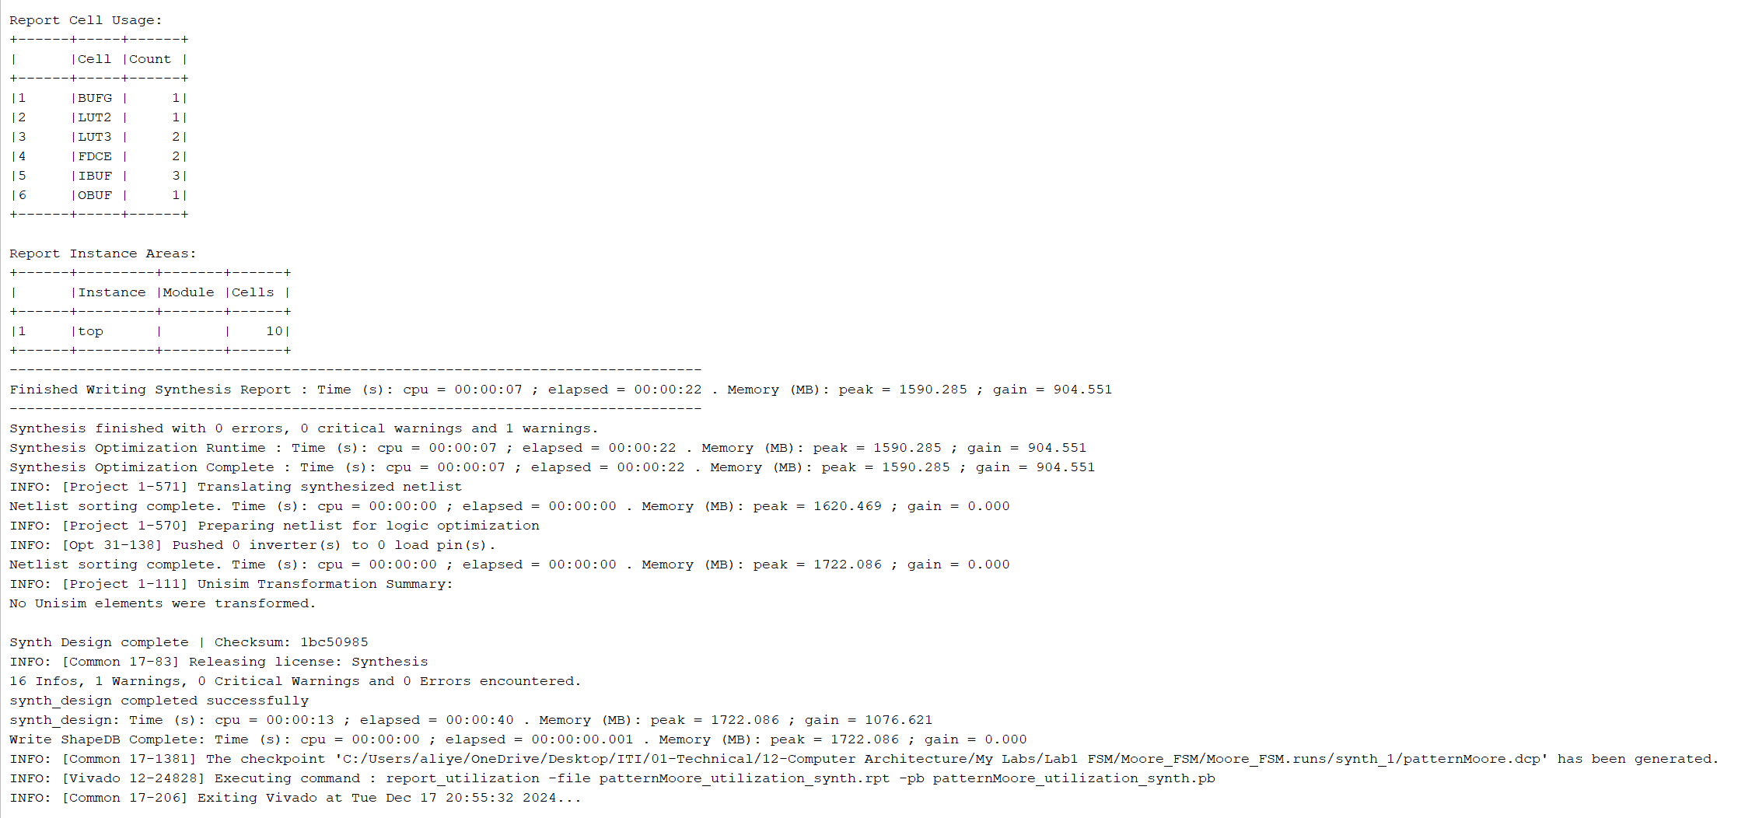

## Changing FSM Encoding Style from auto (binary) to one-hot

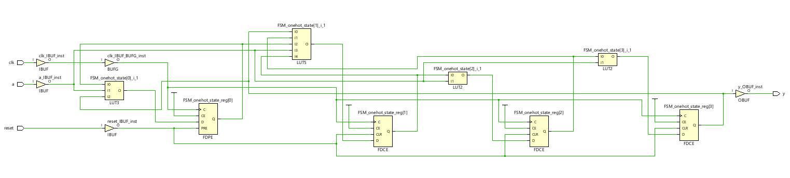

## New Log File for one-hot State Encoding

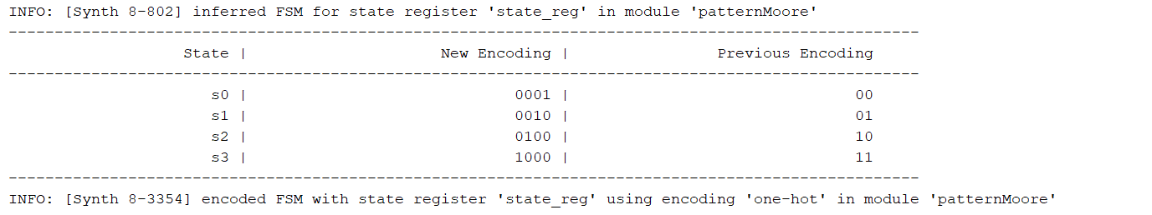

Figure ‎1‑2: Changing to one-hot State Encoding in Vivado.

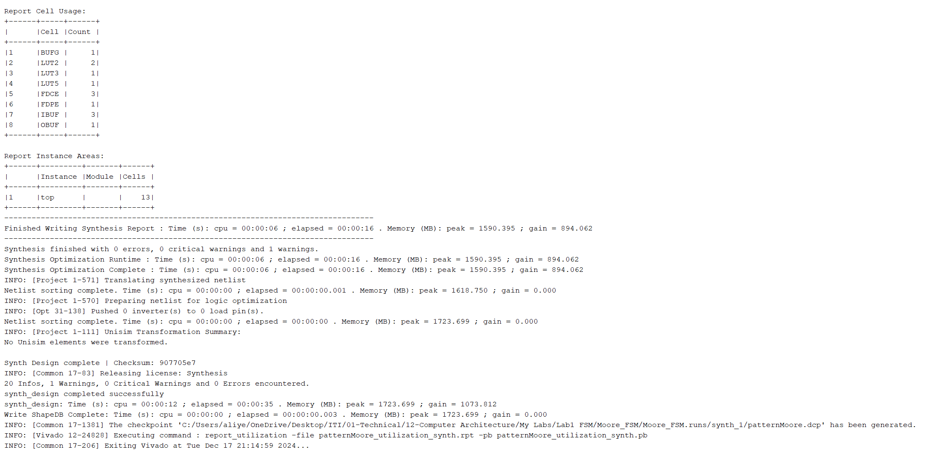

# Mealy FSM Design

## State Transition Diagram for Mealy FSM

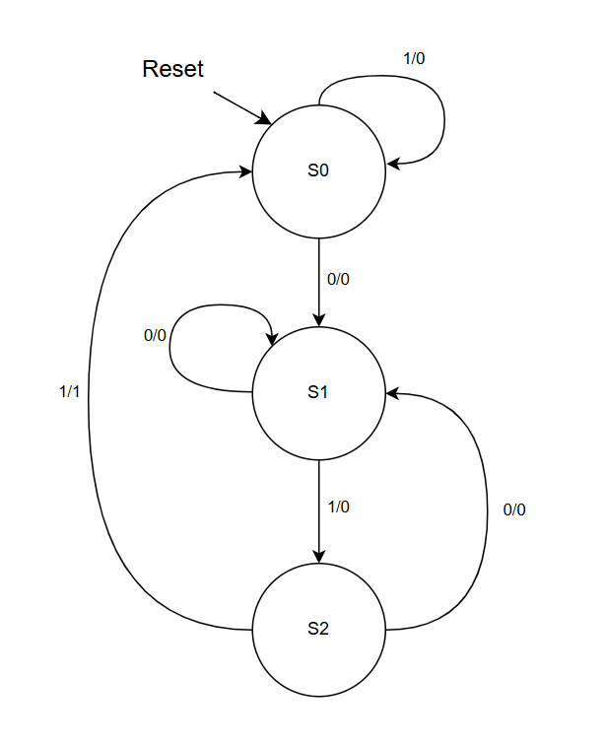

## Mealy FSM VHDL Code

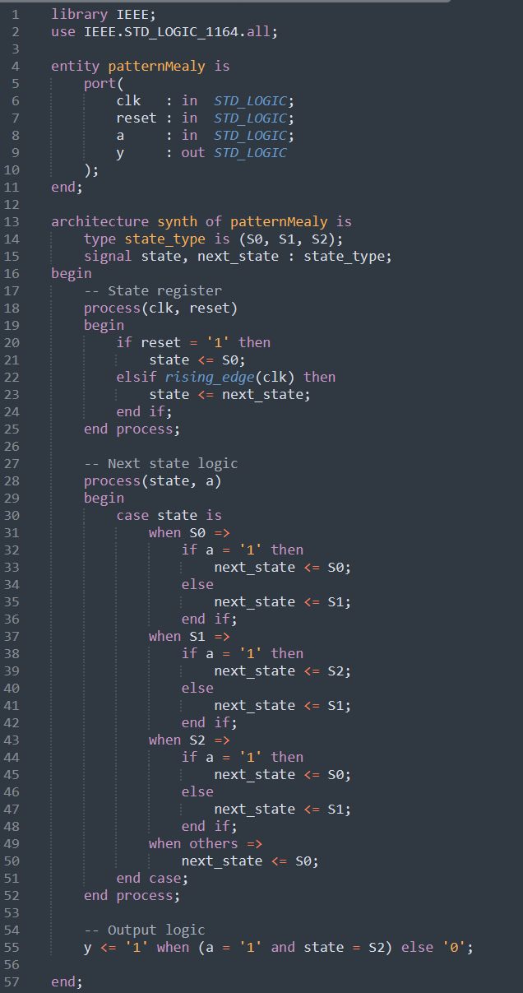

## Mealy FSM Testbench Code

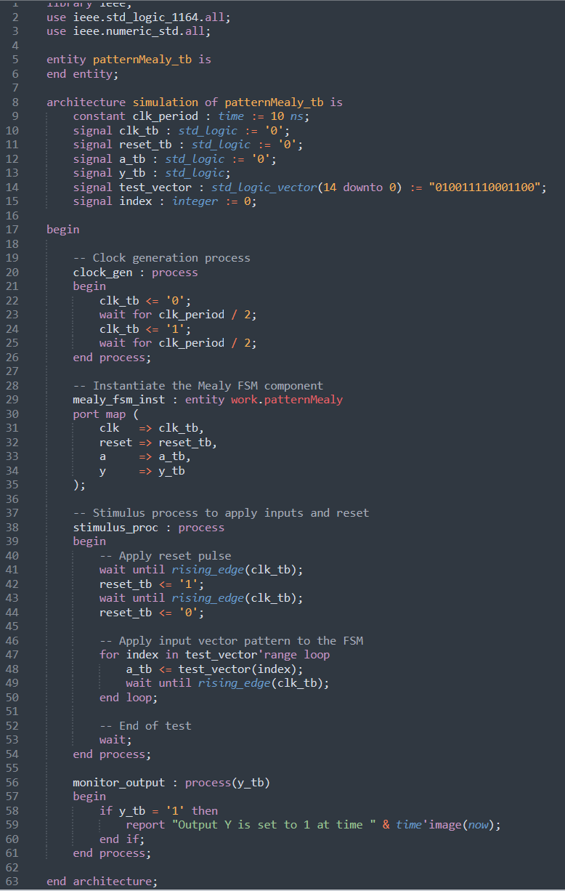

## Simulation Results

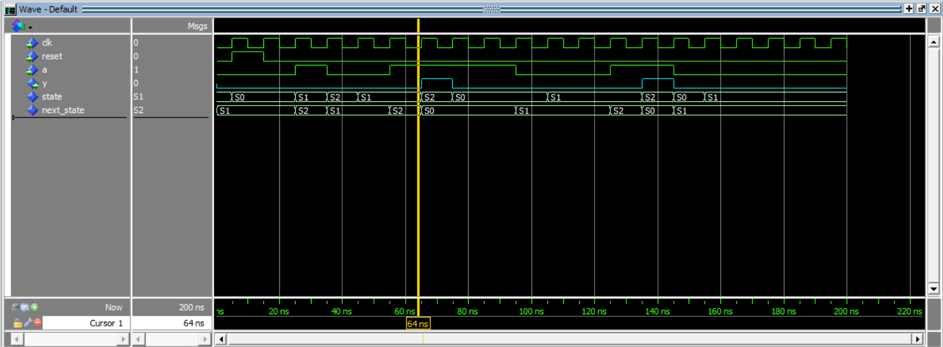

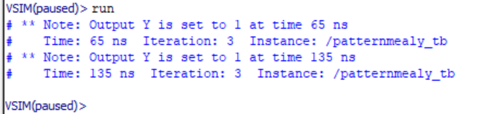

## Synthesis Results for Default Encoding (binary)

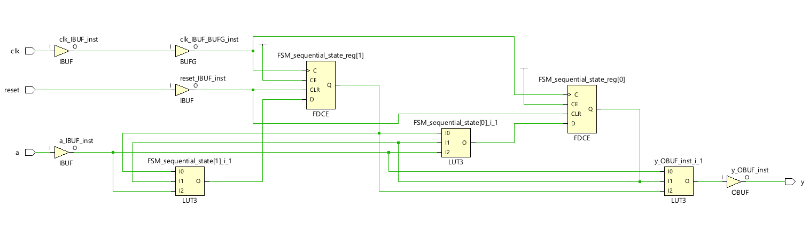

## Log File Output

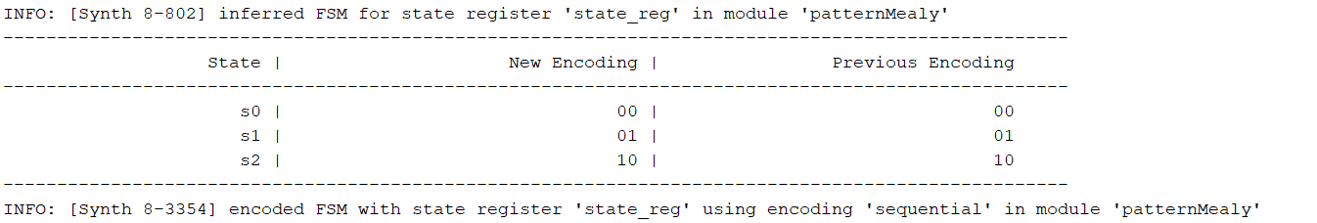

Figure ‎2‑1: Default State Encoding in Vivado

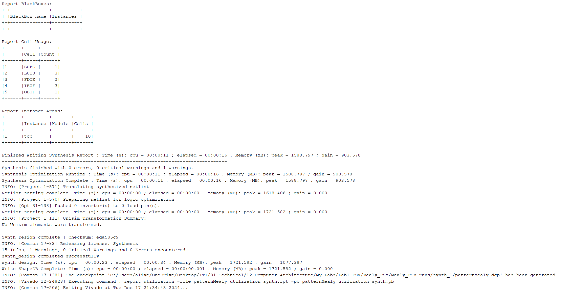.

## Changing FSM Encoding Style to one-hot

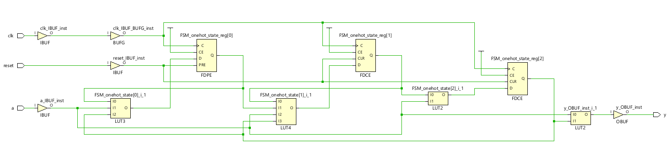

## New Log File for one-hot State Encoding

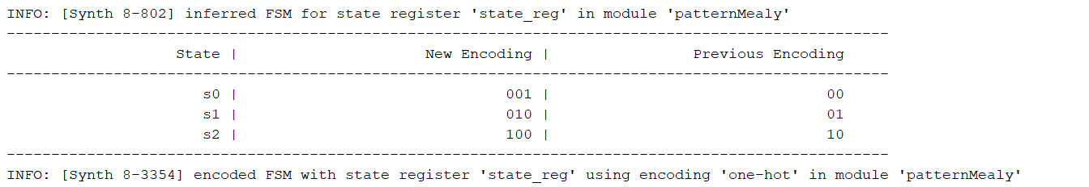

Figure ‎2‑2: Changing to one-hot State Encoding in Vivado.

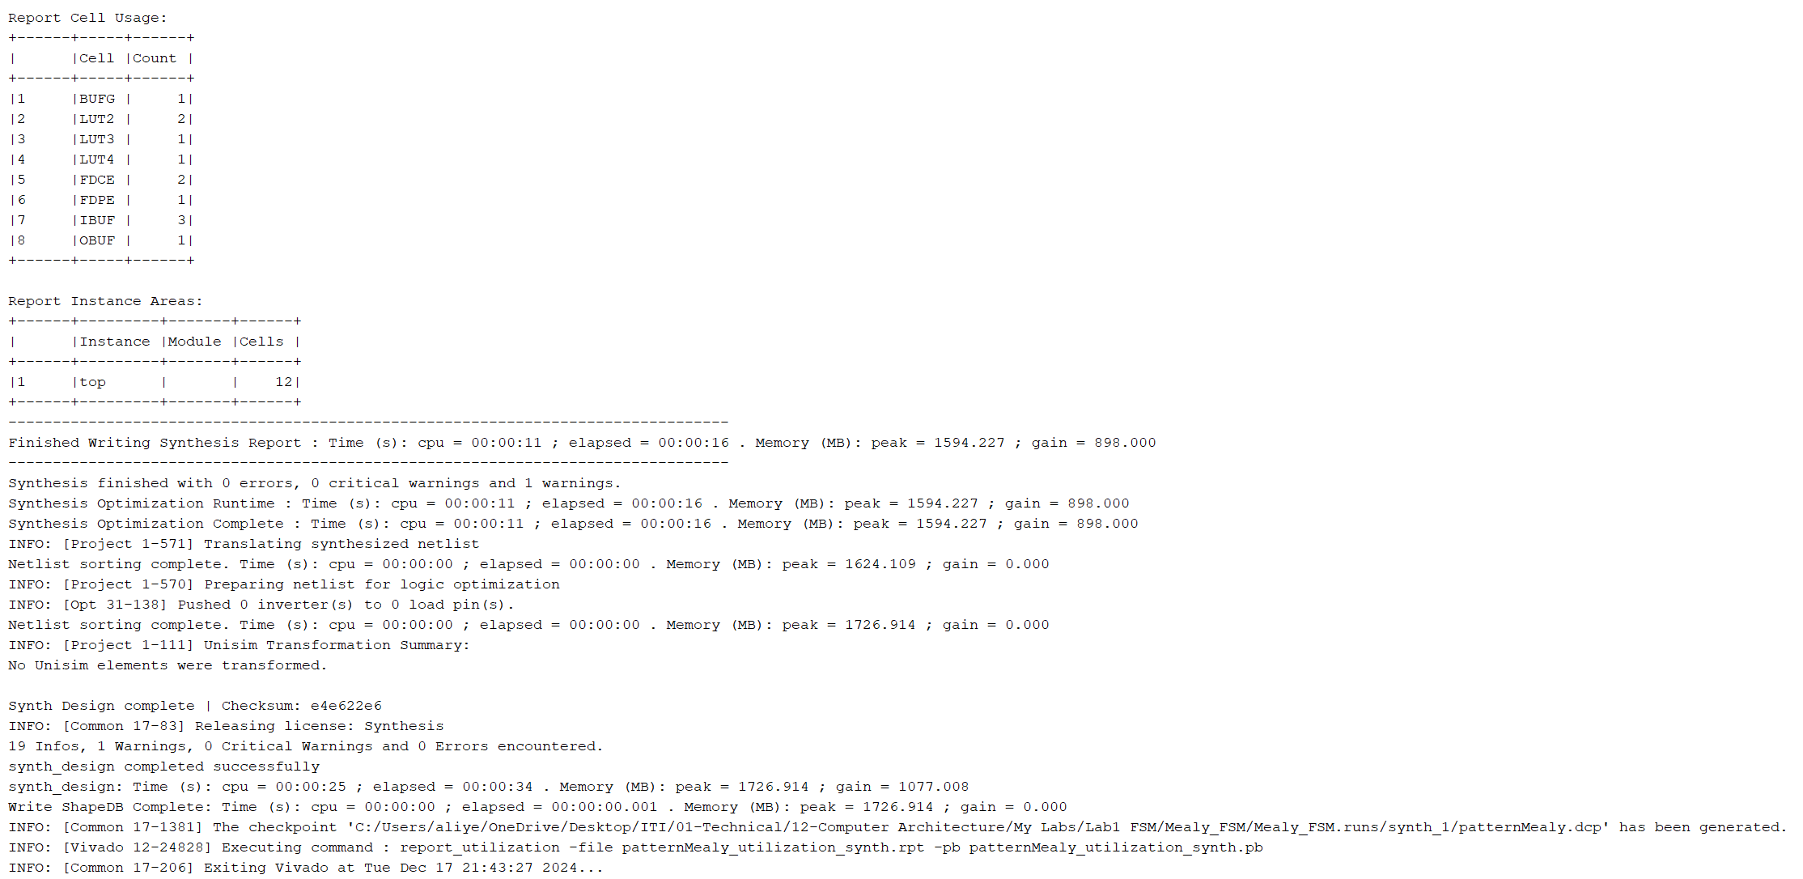

# Differences between Moore and Mealy FSMs

The primary differences between Moore and Mealy FSMs are observed in their state requirements and output dependencies. A Mealy FSM generally requires one fewer state than a Moore FSM to represent the same behavior. Additionally, in a Moore FSM, the output depends solely on the current state, whereas in a Mealy FSM, the output depends on both the current state and the input. These differences are illustrated in the following two figures.



The output depends only on the state

Input here is 0, but the output was still set to 1 upon entering state S3

Figure ‎3‑1: Moore FSM Waveform.



The output depends on both the state and the input.

The output did not change in state S2 because the input was not set to 1

Figure ‎3‑2: Mealy FSM Waveform.